**If Valuations Are Correct, Amazon’s Day 2 Looks Monopolistic**

Amazon is not your typical company. The CEO, Jeff Bezos, describes the business strategy as a perpetual “[Day 1](https://www.fool.com/investing/2017/04/13/jeff-bezos-says-it-will-always-be-day-1-at-amazon.aspx)”[1] where the company retains its start-up mentality and its focus remains on the long term. Profits are therefore re-invested rather than retained or paid out in dividends, as the company seeks to keep expanding. Investors are very much on board with this strategy and their valuation of the company suggests that if “Day 2” does arrive, it will look like nothing we have ever seen before.

Illustrating this point does not require complicated financial analysis. Let’s first look at how Amazon’s current valuation and profitability compare with other companies. Amazon’s [2017 Q1 financial results](http://phx.corporate-ir.net/External.File?item=UGFyZW50SUQ9NjY4MDE1fENoaWxkSUQ9Mzc1OTYyfFR5cGU9MQ==&t=1) show net income of $2.6 billion dollars over the twelve months ending March 31. On a per share[2] basis, the company generated $5.31 in profit. On March 31, the price of one share of Amazon common stock was $886.54, resulting in a price to earnings ratio of 167. Among all S&P 500 companies, the average price to earnings ratio is 25.9[3]. This means that investors are paying a hefty premium for Amazon stock, based presumably on the expectation of higher future returns.

Since its last quarterly report, the Amazon share price has increased more than 12% to over $1000. If we work backward from price, what would the profits and revenue look like if Amazon were valued similarly to a standard company? If Amazon, at $1000 a share, were to have a price to earnings ratio of 20, its earnings would need to increase nearly tenfold to $50 a share, or $24.5 billion dollars a year. Based on the company’s current net profit margin of two percent, more than 1.2 trillion dollars in revenue is required to generate 24.5 billion dollars of profit. To put this into context, this is nearly two and a half times greater than Walmart’s 2016 revenue, which was the largest of any company, and equivalent to 6.7% of GDP. While this analysis is a bit simplistic, it intends to show that Amazon’s current valuation, if correct, predicts an unprecedented situation.

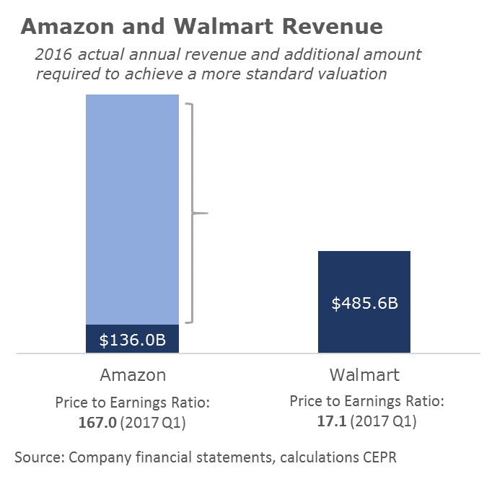

For Amazon to achieve a price to

earnings ratio of 20, an additional

$1,089B of revenue ($1,225B total)

is required at the current net profit

margin and $1000 share price.

Assuming Amazon eventually reaches a valuation comparable to most companies, let’s call this Day 2, there are three possible ways it got there. First, investors may have been overly optimistic. While uncertainty comes with investing, there don’t seem to be many people betting against Amazon. The short interest (the ratio of shared being sold short to total shares in the market) is just above 1.3%, far below the 4.4% average for companies traded on the New York Stock Exchange.

A second possibility is that Amazon’s valuation is correct and the company continues to gain market share and eventually generates revenue levels that have never been seen before. Since revenue is equal to price times quantity, it is possible that Amazon becomes the dominant supplier of more goods and services and obtains a higher revenue through a higher quantity of goods and services sold. To put context around the extent of market share gained required to make this true, a revenue of $1.2 trillion would be exceed the 2015 Census Bureau estimate of all online shopping sales ($434 billion), grocery store sales ($613 billion), and brick and mortar electronics and appliance store sales ($102 billion). It’s an enormous sum. Even if Amazon’s U.S. market share remains unchanged, the company has enormous potential to expand overseas, particularly if new [negotiations](http://www.huffingtonpost.com/entry/state-of-play-in-the-wto-toward-the-11th-ministerial_us_5951365ae4b0f078efd98399) over e-commerce at the WTO proceed in the company’s favor.

The third possibility relates to the profit Amazon makes on each unit of sales. Currently its net profit margin of two percent is low, relative to other retailers but especially relative to other non-retail companies. Retailers of goods that can be easily transported tend to face lots of competition, which keeps prices low and results in slim profit margins. Amazon, with its particularly low profit margins, is often cited as driving down the entire sector profit margins. Traditional brick and mortar retailers, with typically higher overhead, have been [pushed](http://revenueanalytics.com/the-amazon-effect-has-changed-retail/) to lower prices to compete with Amazon. However, as brick and mortar stores continue to close[4] and as Amazon gains market share (including by expanding its own brick and mortar operations, and as discussed above), the competitive price pressures ease. Less competition allows for higher profit margins and higher prices. Amazon could potentially achieve a normal valuation level by increasing its revenue through increased profits from higher prices.

If investors are correct in how they value Amazon’s Day 2, then consumers’ stand to lose either in number of choices or through higher prices. This is an important consideration for those heaping praise over the disruption by Amazon and other large and rapidly growing tech companies.

1. Day 1 is also the name given to Amazon’s headquarters building.
2. Diluted earnings per share trailing twelve months.
3. The historical average PE ratio for S&P 500 companies is 15.7.
4. See [work](https://www.usnews.com/opinion/blogs/economic-intelligence/2012/11/05/private-equity-firms-need-new-rules-for-managing-companies-they-own) by CEPR’s Eileen Appelbaum on the private equity explanation for several retail bankruptcies.